**How to paginate a PDF grid across multiple pages in C#**

The Syncfusion Essential® PDF is a feature-rich and high performance [**.NET PDF library**](https://www.syncfusion.com/document-processing/pdf-framework/net) used to create, read, and edit PDF documents programmatically without Adobe dependencies. Using this library, you can paginate PDF grid across multiple pages using C#.

**Steps to add pagination in pdf grid programmatically:**

1. Create a new console application project.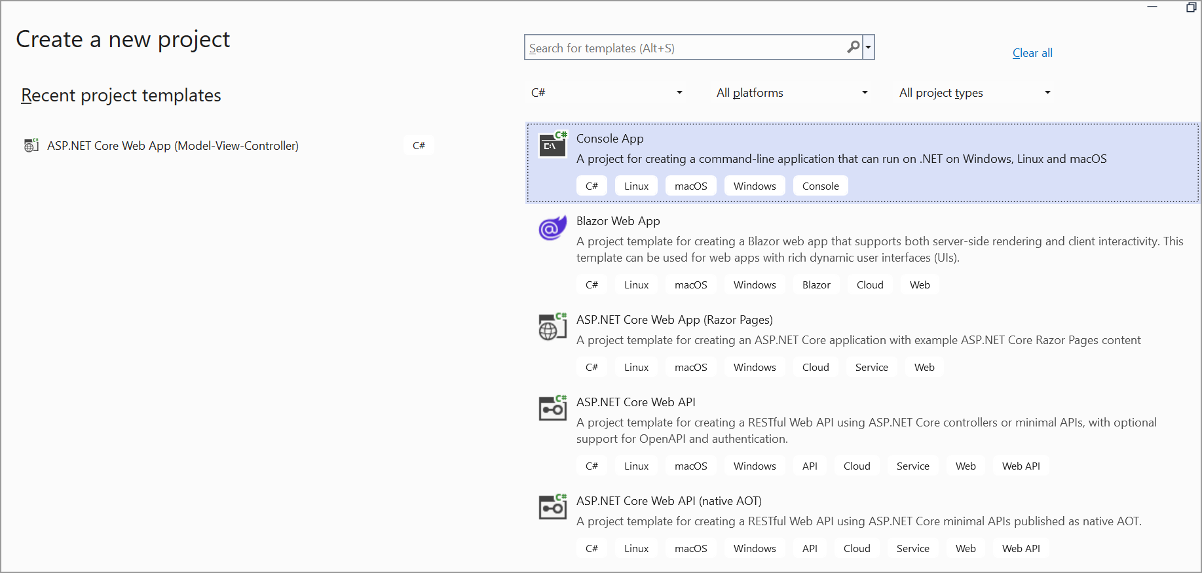
2. Install the **[Syncfusion.Pdf.Net.Core](https://www.nuget.org/packages/Syncfusion.Pdf.Net.Core" \t "_blank)** NuGet package as a reference to your console application from [**Nuget.org**](https://www.nuget.org/).

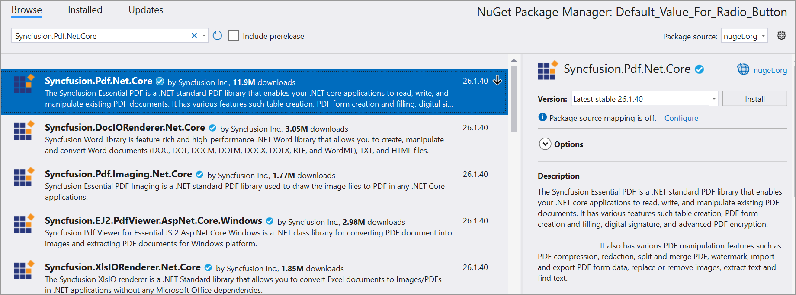

1. Include the following namespaces in the Program.cs file.

**C#**

using **Syncfusion**.Pdf.Graphics;

using **Syncfusion**.Pdf.Grid;

using **Syncfusion**.Pdf;

using **Syncfusion**.Drawing;

1. Use the following code sample in Program.cs to add pagination in pdf grid.

**C#**

// Create a new PDF document

**PdfDocument** document = **new** **PdfDocument**();

// Add a new page to the document

**PdfPage** page = document.Pages.**Add**();

// Create and draw PDF grid

**AddGrid**(page);

// Create a memory stream to save the document

**MemoryStream** stream = **new** **MemoryStream**();

// Save the PDF document to the memory stream

document.**Save**(stream);

// Close the document and release resources

document.**Close**(true);

// Write the PDF file to disk

**File**.**WriteAllBytes**(@"OutputPdf.pdf", stream.**ToArray**());

// Method to add content to the PDF page

**void** **AddGrid**(**PdfPage** page)

{

// Create a new PDF grid

**PdfGrid** grid = **new** **PdfGrid**();

// Add 2 columns to the grid

grid.Columns.**Add**(2);

// Add a header row to the grid

grid.Headers.**Add**(1);

// Access the header row

**PdfGridRow** pdfGridHeader = grid.Headers[0];

pdfGridHeader.Cells[0].Value = "Tittle";

pdfGridHeader.Cells[1].Value = "Description";

// Loop to add multiple rows to the grid

**for** (int j = 0; j < 7; j++)

{

// Add a new row to the grid

**PdfGridRow** pdfGridRow = grid.Rows.**Add**();

// Set values for the row cells

pdfGridRow.Cells[0].Value = "Software";

pdfGridRow.Cells[1].Value = "Building on previous innovations in mathematics and technology, software was created for the programmable digital computers that emerged in the late 1940s and was necessary to realize their usefulness. The first software was tied closely to the underlying computer hardware, but over time, the lower layers of the system have become more standardized, and software has become increasingly portable between different systems and abstracted from the underlying machine code. Operating systems manage the hardware resources and mediate between different applications that accomplish tasks for the user. Programming languages are the format in which software is written, and must be both human-readable and capable of being translated into unambiguous instructions for computer hardware. Compilers or interpreters are needed to link a program with other code that it relies on and convert the software into machine code that can be executed on the hardware.";

}

**PdfGridLayoutFormat** layoutFormat = **new** **PdfGridLayoutFormat**

{

// Fit grid to the page, break if needed

**Break** = **PdfLayoutBreakType**.FitPage,

// Paginate the grid if it spans multiple pages

**Layout** = **PdfLayoutType**.Paginate

};

// Draw the grid on the page at specified position

grid.**Draw**(page, **new** **PointF**(0, 200), layoutFormat);

}

A complete working sample can be downloaded from [**Add\_Paginate\_in\_PDFGrid.zip**](https://www.syncfusion.com/downloads/support/directtrac/general/ze/Add_Paginate_in_PDFGrid-1271536482.zip)

By executing the program, you will get the PDF document as follows.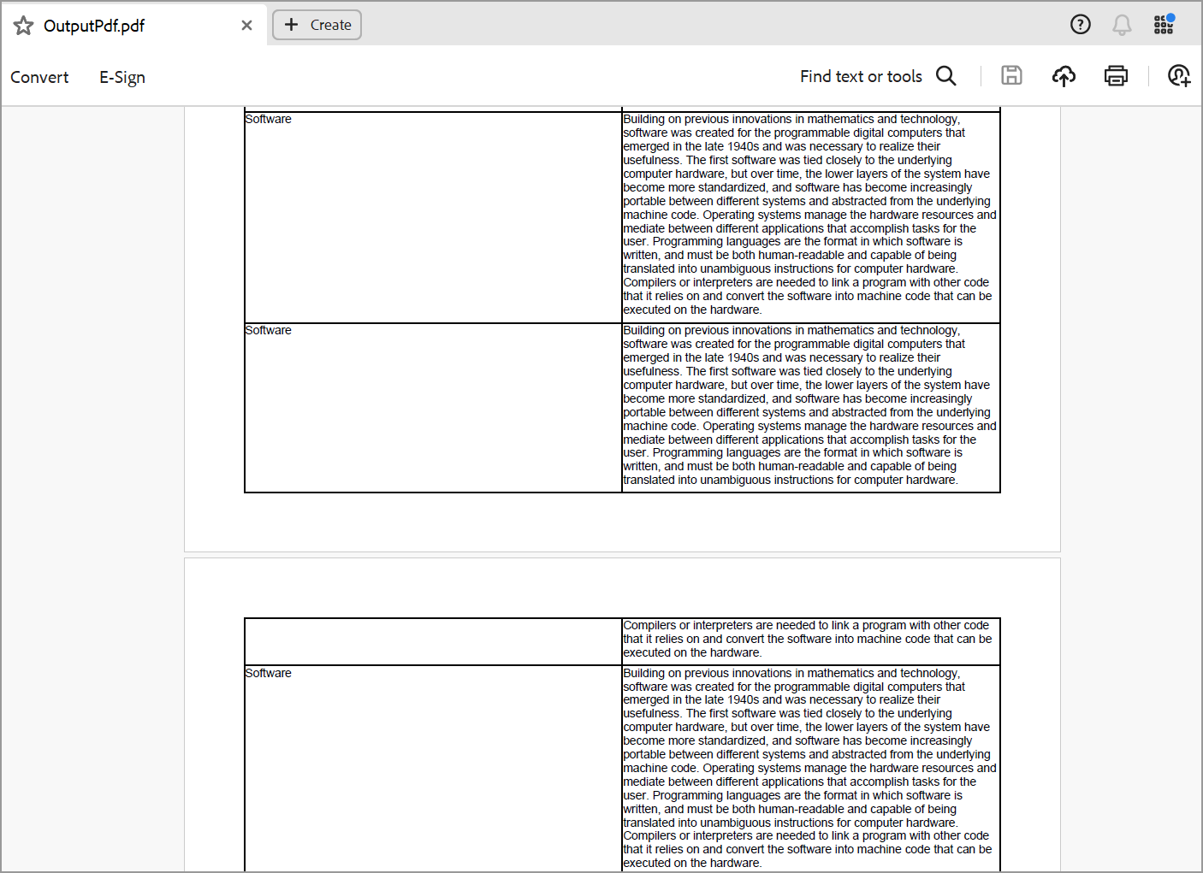

Take a moment to peruse the documentation for [**using Grid in PDF document**](https://help.syncfusion.com/file-formats/pdf/working-with-tables), where you will find other options like support for [**cell customization**](https://help.syncfusion.com/file-formats/pdf/working-with-tables#cell-customization-in-pdfgrid), [**rows**](https://help.syncfusion.com/file-formats/pdf/working-with-tables#row-customization-in-pdfgrid) and **[columns](https://help.syncfusion.com/file-formats/pdf/working-with-tables" \l "columns-customization-in-pdfgrid" \o "columns" \t "_blank)**customization, and [**built in table styles**](https://help.syncfusion.com/file-formats/pdf/working-with-tables#built-in-table-styles), [**pagination**](https://help.syncfusion.com/file-formats/pdf/working-with-tables#pagination-in-pdfgrid).

Refer [**here**](https://www.syncfusion.com/document-processing/pdf-framework/net)to explore the rich set of Syncfusion Essential® PDF features.